CLASS DESIGN
- Class “deleteProductController”
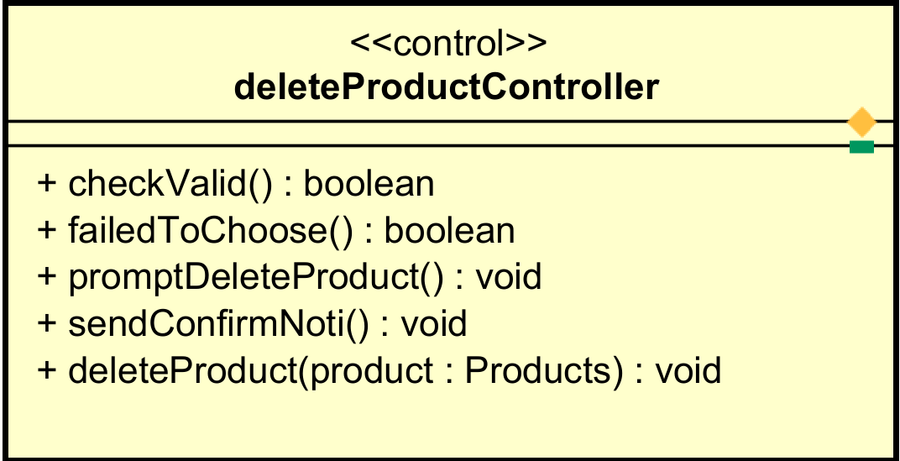

Attribute None
Operation
# | Name |  | Return type | Description (purpose)
1 | checkValid |  | boolean | Check if the product manager has deleted more than 30 items. If so, check whether the number of selected items for deletion exceeds 10. If it does, do not allow further selection.
2 | failedToChoose |  | boolean | When the product manager selects more than the allowed quantity, a message will appear on the screen stating that no more products can be selected.
3 | promptDeleteProduct |  | void | A confirmation prompt appears asking the product manager to confirm whether they want to delete the selected items or not.
4 | sendConfirmNoti |  | void | Send a confirmation notification stating that the items have been successfully deleted from the store or not.
5 | deleteProduct |  | void | Delete the item’s data from the database.

Parameter:
- IDProduct – ID product used to search product.
Exception:
- + deleteProductException: if the database deletion is failed
State None
Method None

- Class “updateProductController”
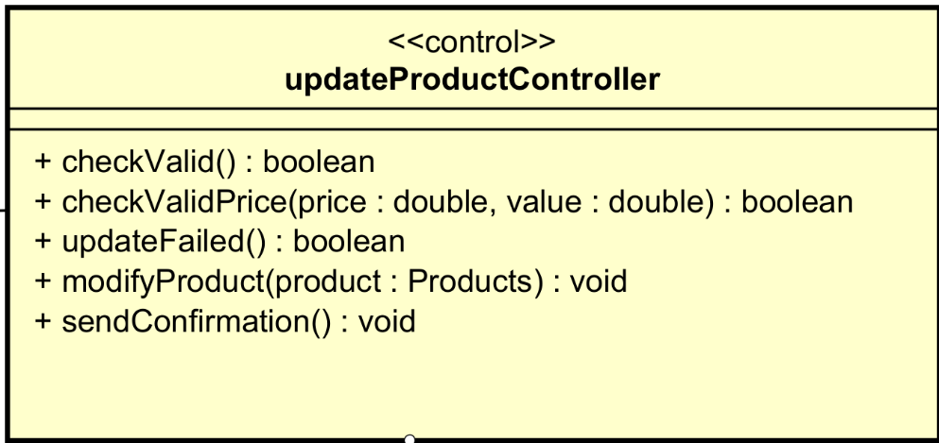
Attribute
None
Operation
# | Name | Return type | Description (purpose)
1 | checkValid | boolean | Check if the product manager has filled in all the required fields.
2 | checkValidPrice | boolean | Check if the price of the product is between 30% and 150% of the product value to avoid price inflation or undercutting.
3 | updateFailed | boolean | Check if all the above conditions are met, then proceed to update the item data.
4 | modifyProduct | void | Modify the item’s data from the database.
5 | sendConfirmation | void | Send a confirmation notification stating that the items have been successfully modified in the database or not.
Parameter:
- product – product information.
Exception:
- viewException: if the database modification is failed
Method None
State None

- Class “addProductController”

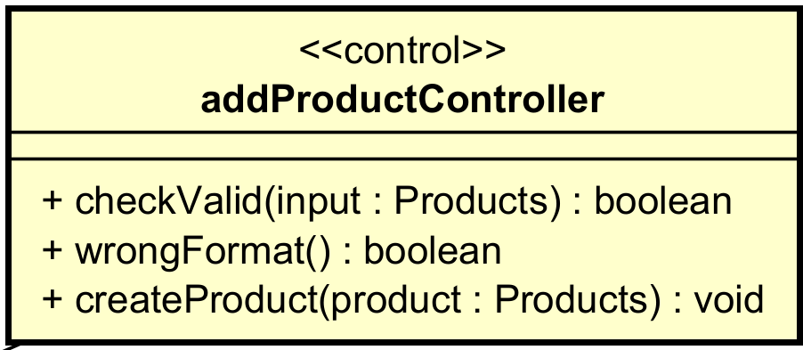

Attribute None
Operation
# | Name | Return type | Description (purpose)
1 | checkValid | boolean | Check if the product manager has filled in all the required fieldswith appropriated format.
2 | wrongFormat | boolean | If the product manager enters the wrong format, they will need to re-enter the incorrect fields.
3 | createProduct | void | Create data for the product in the database.

Parameter: None
Exception: createProductException : If adding the item to the database fails, display an error message and prompt the product manager to try again.

State None
Method None

- Class “Product”
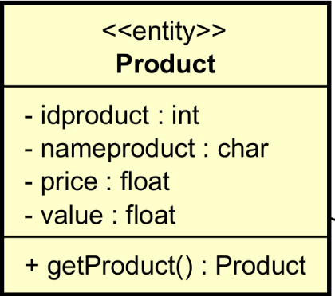

Attribute

# | Name | Data type | Default value | Description
1 | id | Int | NULL | Id of the product
2 | nameproduct | String | NULL | Name of the product
3 | price | float | NULL | Price of the product
4 | value | double | NULL | Value of the product

Operation
# | Name | Return type | Description (purpose)
1 | getProduct | Product | Return product infomation

Parameter: None
Exception: None
Method None
State None

- Class “updateProductScreen”

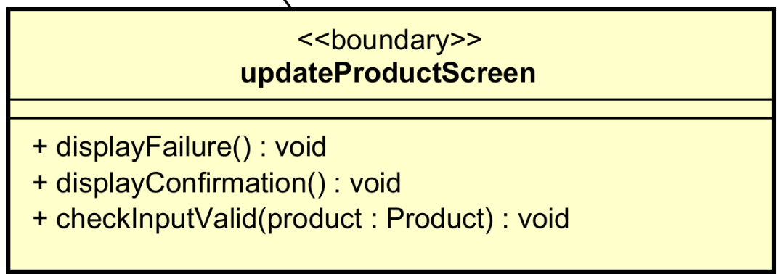

Attribute
Operation
# | Name | Return type | Description (purpose)
1 | displayFailure | void | If the product manager enters incorrect information or the item's price deviates too much from its actual value, prompt them to review and correct the input.
2 | displayConfirmation |  | Display the confirmation the updating progress status
3 | checkInputValid | boolean | Calling the checkValid of the updateProductController

Parameter:
Exception:
Method None
State None
- Class “addProductScreen”

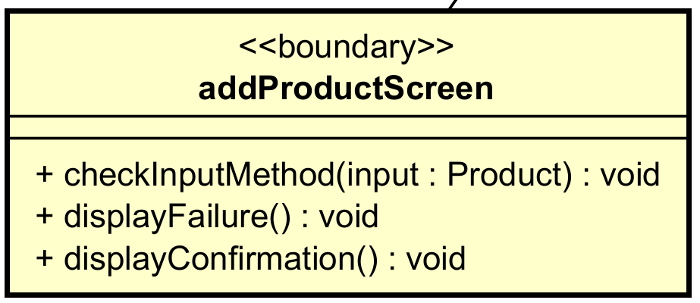

Attribute
Operation
# | Name | Return type | Description (purpose)
1 | checkInputMethod | void | Confirm to deduct money from card to pay for renting bike
2 | displayFailure | void | Display the failure and prompt them to review and correct the input.
3 | displayConfirmation | void | Display the confirmation the adding progress status is succesfull or not

Parameter:
Exception: None
Method None
State None
- Class “ListProductScreen”

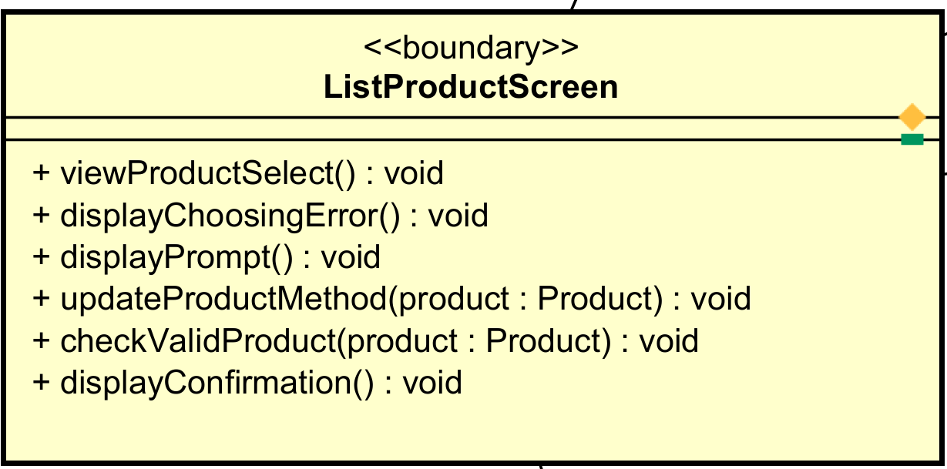

Attribute
Operation
# | Name | Return type | Description (purpose)
1 | viewProductSelect | void | View the information of the product
2 | displayChoosingError | void | Selection is not allowed because either the limit of 10 products has been exceeded or more than 30 products have already been deleted in a day.
3 | displayPrompt | void | Display a prompt asking the user to confirm whether they want to delete the selected items or cancel the deletion.
4 | updateProductMethod | void | If the user selects the option to edit a product, call updateProductScreen
5 | checkValidProduct | void | Call the checkProduct of the deleteProductController
6 | displayConfirmation | void | Display the confirmation the deleting progress status is succesfull or not

Parameter:
- amount: total amount that interbank will deduct from customer’s card
- content: content of transaction
Exception: None
Method None
State None

